 |  |  | The Biodynamic approach to soil fertility is to enhance, strengthen and balance the life forces within the soil  and impart this vitality to the plants  we grow.  “I really got an enormous amount out of your  course and I know it has really empowered me to  move to the next stage of my BD journey,  thank you.  I had read many BD books prior to the course but  I thought how you structured and presented the  topic was excellent. So keep up your good work  I am sure many more people will come away with  the same feelings as I have.”  Nicholas Pook, Primrose Hill Farm,  Hunter Valley  “I have been able to quickly grasp the ideas  and practice covered in the course. The teaching techniques, combining lectures, handouts, visual instruction and plenty of light-hearted interaction  have helped in my rapid coming to grips with BD.  The course has inspired me and has opened up a  whole new dimension to gardening/agriculture  for me.  I am thoroughly enjoying the course and  would recommend it to anyone with an interest in gardening/agriculture and Nature.”  Peter Hammond Canberra |  | Course Tutor  Walter Kohler-Bond has taught Horticulture and Landscaping, Conservation issues and Permaculture for many years at TAFE, Adult education and also conducted workshops privately in Permaculture, Bush Food and Beekeeping.  Walter is a qualified Horticulturalist and registered Permaculture teacher and an Accredited trainer and Workplace Assessor.  He lives with his family on a small property on the NSW South Coast.  Walther graduated from the Biodynamic Education Centre under the tutorlage of Lynette West and has been an enthusiastic teacher with the Biodynamics Education Centre for over 15 years.  For more information contact  email:  courses@biodynamiceducation.com  Ph Walther 02 4474 3971 or  or visit our web site on  www.biodynamiceducation.com | 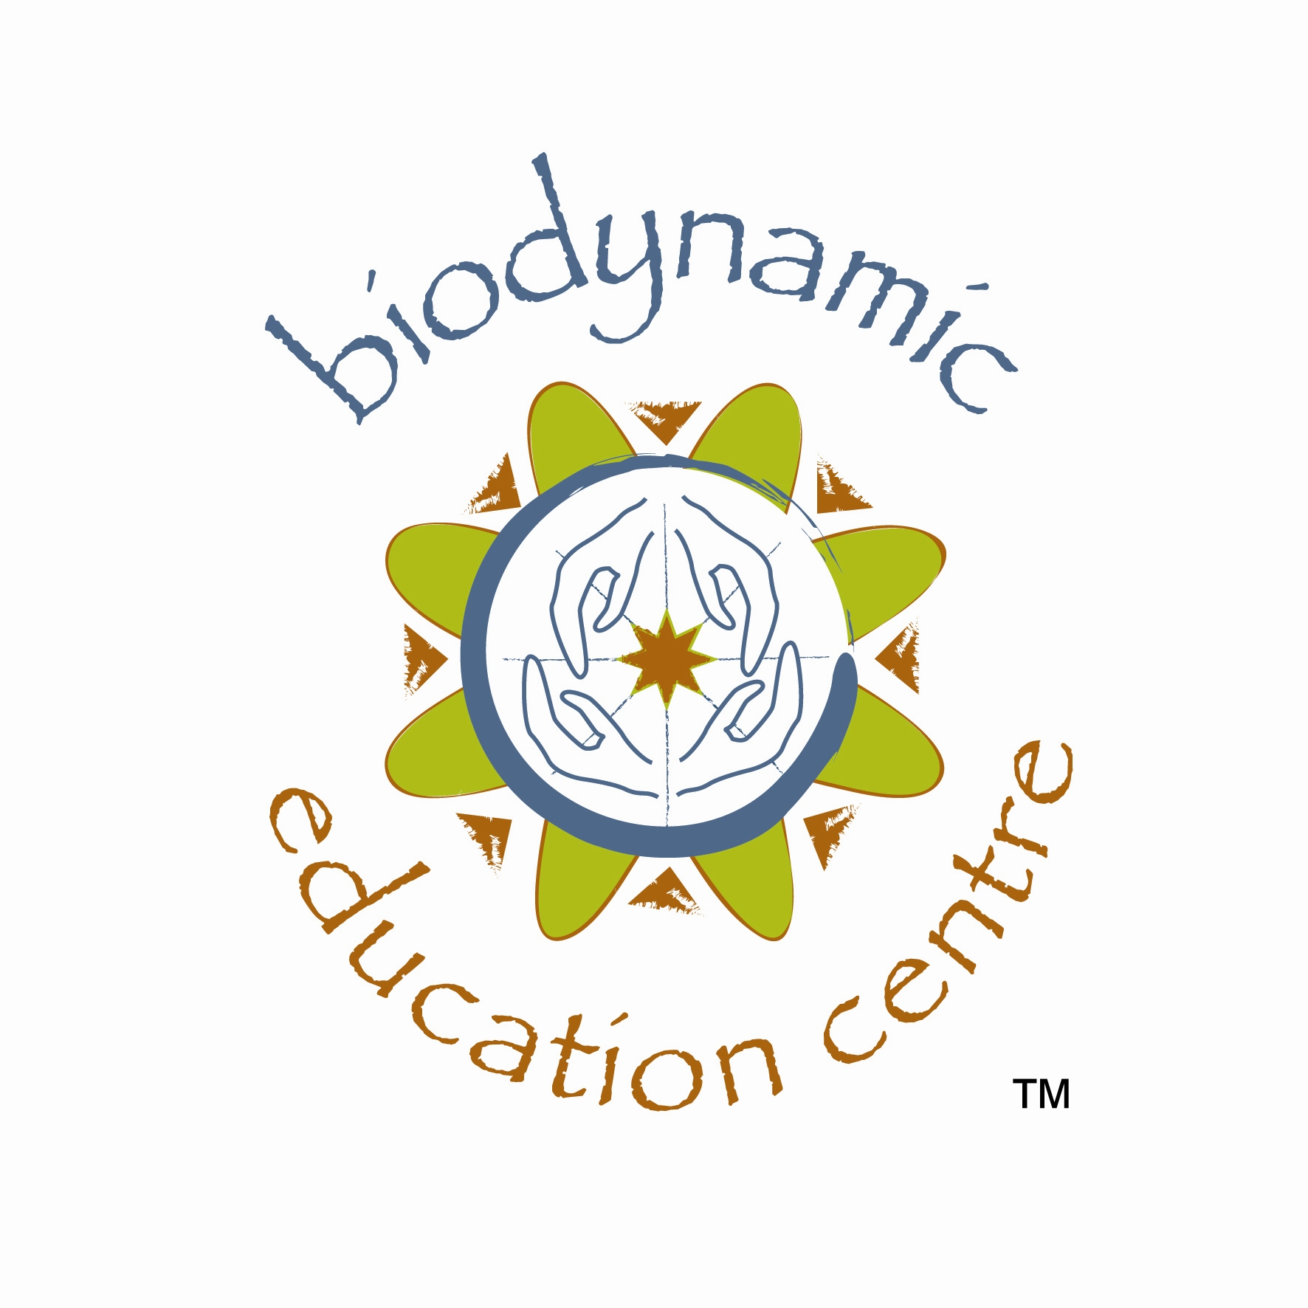  The Biodynamic Education Centre . presents the Foundation Course for  Biodynamic  Farming and  Gardening  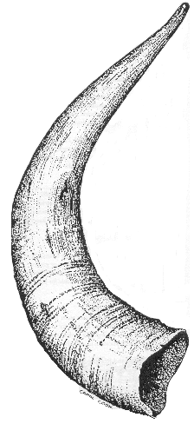  May 2020  Marananga  S.A. |  | This training course offers you  a unique opportunity to  participate in a competency  based program for biodynamic agriculture.  The Foundation Course uses a  variety of mediums; lectures, group activities and creative, hands-on practices to develop knowledge of biodynamic farming and gardening practice.  Through attendance on this  training course you will gain a  very thorough understanding of the biodynamic system and develop  the skills and knowledge to work  with the biodynamic system in your individual situation.  Course structure  Designed as three learning modules, each module takes two days to complete.  Course dates  Dates for the course are:  Evening lecture:  Sunday 3rd May 2020  Level One: Monday 4th  & Tuesday 5th May 2020  Level Two: Thursday 7th &  Friday 8th May 2020  Level Three: Monday 11th &  Tuesday 12th May 2020.
 |  |  | 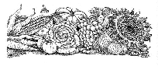
 |  |  |  | Level One  Session Summaries  Evening Lecture (6.30-8.30)_____________  Module 1. The History of Agriculture  Aim of Session-To explore the need for a new outlook  for agriculture, one which encompasses the totality of  Nature. We identify how biodynamic agriculture can  solve many of the problems associated with conventional agriculture through a science that is in harmony with the  very essence of Nature.  Day 1_(9am-5pm)______________________  Module 2. The Role of the Biodynamic Preparations  Aim of Session-To identify why the biodynamic  preparations were developed and their role in revitalising  the earth, plants, animals and ultimately man himself.  Module 3. Two Realms of Existence  Aim of Session-To explore the invisible realm of forces  in Nature and to understand that what we see manifested  in the physical world is the result of the interplay  of these forces.  Module 4. The Role of BD500  Aim of Session-To identify the role of BD500 and  learn of the many benefits that can be achieved by  using this preparation. We look at how BD500 is made  and the scientific principles behind this process.  Module 5. The Art of Vortex Stirring  Aim of Session-To explore the different stirring methods used when applying BD500 and to learn the process of vortex rhythmic stirring.  Day 2_(9am-5pm)_____________________  Module 6. Using the Biodynamic Planting Calendar  Aim of Session-To identify how the moon influences  different aspects of plant growth. We learn to use these influences to increase the vitality and strength of our plants.  Module 7. Rhythms in Nature  Aim of Session-To learn to work in harmony with the rhythms in nature; the daily, lunar and seasonal cycles of  Nature which we use when working with plants and  applying the biodynamic preparations.  Module 8. Balancing Excesses in Nature  The Role of BD508  Aim of Session-To explore what influences lead to  the development of fungal diseases in plants and how  these can be effectively controlled by the biodynamic  preparation known as BD508.  Module 9. Applying BD508  Aim of Session-To learn the equipment needed for the  application of BD508. We learn to stir and apply this  preparation. | Level Two  Session Summaries  Day 1_(9am-5pm)______________________  Module 10. Within The Living Realm  Aim of Session-To explore what Rudolf Steiner referred  to as ‘within the living realm’ and how this principle  should be a guide for all our agricultural practices.  We learn the vital importance of the correct feeding of  the plant through elements that are colloidally bonded  to an organic molecule.  Module 11. BD Preparations BD502 to 507  Aim of Session-To learn the role the biodynamic compost preparations have in bringing order and balance to composting processes, where organic matter is transformed into colloidal humus.  Module 12. Biodynamics - A Total Farming System  Aim of Session-To learn of the many components of Biodynamic farming that work together to create a  healthy and sustainable farming or gardening system and how by using biodynamic principles we can overcome  many of the problems we currently see in agriculture today.  Module 13. Practical - Making Manure Concentrate  Aim of Session-To learn how to make and apply this  manure concentrate which stimulates soil metabolism,  enhances growth and increases crop yields.  Day 2_(9am-5pm)______________________  Module 14. Balancing the Forces. Role of BD501  Aim of Session-To identify how to apply this powerful preparation to produce crops of the highest nutritional  value, with the best flavour, strongest seeds and enhanced keeping qualities.  Module 15. The Important Role of Humus  Aim of Session-To learn of the key role the formation  of humus plays in the sustainability of the farm or  garden; how it balances soil pH, improves CEC and  acts as a chelating agent to make minerals available  for plant growth.  Module 16. The Element of Water  Aim of Session-To learn the vital role water has in  Nature and how its capacity to support life is determined  by its quality. We explore the use of flowforms in revitalising water systems.  Module 17. Taking and Reading Soil Profiles  Aim of Session- To learn how proper soil structure is as important to the success of farming or gardening as the chemistry and humus production. To learn to take soil profiles and understand how soils in a biodynamic  system should develop. |  | Level Three  Session Summaries  Day 1_(9am-5pm)_______________________  Module 18. The Vortex - Connecting With the  Universal Laws of Life  Aim of Session- To identify the importance of creating the vortex and chaos movements used when stirring the biodynamic preparations. To explore how through this movement we are connecting with the universal laws  governing all life on Earth and are able to make the forces  of the cosmos effective in the earthly realm.  Module 19. The Art and Science of Compost Making  Aim of Session- To learn the art and science of biodynamic compost techniques to ensure the conditions for proper composting are met which lead to the production of stabilised humus. We learn to create an environment in the compost where the even decomposition of materials takes place with minimal loss of nutrients.  Module 20. Practical - Building a Biodynamic  Compost  Aim of Session-To learn the requirements for the building  of a biodynamic compost heap, the correct materials, site  and physical requirements.  Practical activity-We build a biodynamic compost and work through all that was covered in the previous session.  Day 2_(9am-5pm)_______________________  Module 21. Formative Forces in Nature  Aim of Session-To explore the need to develop a conscious awareness of the dynamic interplay of forces in Nature. We explore the effects of the formative forces on the forms and appearances in the physical world and how the biodynamic  preparations can be used to enhance the formative forces in nature.  Module 22. Biodynamic Methods of Pest and  Weed Control  Aim of Session-To learn to use the biodynamic technique  called ‘peppering’ to clear an area of a certain weed, animal  or insect that is not in balance with the environment.  Module 23. The Farm as a Self Contained Unit,  Green Manuring and Crop Rotations  Aim of Session-To learn to develop the farm’s own resources  to the point where production, quality and quantity will  sustain a balanced farming system.  Module 24. Practical - Tree Pasting  Aim of Session-To learn how to make and apply biodynamic tree paste which is used for its beneficial influence upon the health of the tree, its cambium, sap circulation and therefore  its proper nutrition. | Course venue: Marananga, SA  To register for the Foundation Course:  Email courses@biodynamiceducation.com  or phone Walther 0244743971  Places are strictly limited  Course fee $1155.00  (Pension Concession $880.00)  *a deposit of $400 is required at registration  Please make cheques payable to  Biodynamic Education Centre  Biodynamic Education Centre  P.O. Box 1017  Queanbeyan  NSW 2620  Australia  Registration Form  Name…………………………………….  Address…………………..….…………..  …………………..…………..…………..  …………………………………………..  Phone………………………..…………..  Mobile……………………..………………..  Email………………………………………

